Final Project Report Template

Alzheimer Disease Prediction

**1.Introduction:**

* 1. **Project Overview:**

Alzheimer's disease is a progressive neurological disorder that affects millions worldwide, causing memory loss, cognitive decline, and behavioral changes. Early diagnosis of Alzheimer’s is crucial for effective intervention, as it can significantly improve the quality of life for patients and their families. However, traditional diagnostic methods are often time-consuming, expensive, and prone to human error. Deep learning has emerged as a powerful tool in medical imaging, enabling automated and accurate detection of diseases. In this project, we aim to develop a deep learning-based model for the early prediction of Alzheimer’s disease using MRI scans. By leveraging advanced techniques like Convolutional Neural Networks (CNNs), our solution aspires to provide a scalable and reliable alternative to conventional diagnostic methods.

* 1. **Project Objectives:**
* To develop a deep learning model capable of predicting the risk of Alzheimer’s disease early using brain imaging.
* To build and evaluate a robust predictive model through comprehensive steps, including data collection, preprocessing, model development, and deployment.
* To create a user-friendly application aimed at assisting researchers and healthcare professionals.

1. **Project Initialization and Planning Phase:**
   1. **Define Problem Statement:**

Many individuals and their families face significant uncertainty and distress when dealing with the possibility of Alzheimer’s disease. They struggle with delayed diagnosis due to invasive tests, and expensive diagnostic tools that are often inaccessible or unaffordable. This delay prevents timely intervention, limiting the ability to slow disease progression or make informed care decisions. Patients and caregivers desire a solution that provides an early, accurate prediction. They want an affordable, easy-to-use, and reliable tool that empowers them to take control of their health, plan for the future, and access treatments or support at the right time. This understanding highlights the emotional, financial, and logistical challenges customers face, helping us design solutions that meet their needs and improve their experience.

**Problem Statement Template:Click Here**

* 1. **Project Planning:**

The project will be executed in phases, starting with data collection and preprocessing to prepare high-quality MRI datasets. Next, a deep learning model using CNNs will be developed and optimized through hyperparameter tuning. Finally, the model will be deployed via a user-friendly interface for clinical use. The project will be completed, with key milestones for data preprocessing, model development, optimization, and final deployment.

**Project Planning Template: Click Here**

* 1. **Project Proposal:**

We propose developing a deep learning-based solution for the prediction of Alzheimer’s disease using MRI imaging. This solution will employ advanced Convolutional Neural Networks (CNNs) to accurately classify the stages of Alzheimer’s disease, focusing on primary categories: Normal and Demented. By leveraging CNNs, the model will automatically extract complex patterns and features from MRI images, enabling efficient and precise diagnosis. The solution will be deployed as a user-friendly application, enabling reliable, automated, and scalable diagnostics to assist healthcare professionals.

**Project proposal Template:** [**Click Here**](https://github.com/Akshaya-143/Alzheimer-Disease-Prediction/blob/main/Alzheimer/1.%20Project%20Initialising%20and%20Planning%20Phase/Project%20Proposal%20(Proposed%20Solution)%20Template.pdf)

1. **Data Collection and Preprocessing Phase:**
   1. **Data Collection Plan and Raw Data Sources Identified:**

We will collect MRI imaging datasets from publicly available sources such as Kaggle, ensuring they are of high quality and properly labeled for classification categories. The preprocessing phase will involve resizing images to a consistent dimension, normalizing pixel values, and applying data augmentation techniques like flipping and rotation to enhance model generalization. The dataset will then be split into training, validation, and test sets to ensure reliable model evaluation and performance assessment.

**Data Collection Plan & Raw Data Sources Identification Template:** [**Click Here**](https://github.com/Akshaya-143/Alzheimer-Disease-Prediction/blob/main/Alzheimer/2.%20Data%20Collection%20and%20Preprocessing%20Phase/Raw%20Data%20Sources%20And%20Data%20Quality%20Report%20Template.pdf)

* 1. **Data Quality Report:**

This dataset has been checked for essential quality criteria, including label accuracy, image quality, annotation consistency, and class balance. No significant data quality issues were identified. This clean dataset is suitable for the Xception model training without further adjustments.

**Data Quality Report Template:** [**[Click Here](https://github.com/Akshaya-143/Alzheimer-Disease-Prediction/blob/main/Alzheimer/2.%20Data%20Collection%20and%20Preprocessing%20Phase/Data%20Preprocessing%20Template.pdf)**](https://github.com/Akshaya-143/Alzheimer-Disease-Prediction/blob/main/Alzheimer/2.%20Data%20Collection%20and%20Preprocessing%20Phase/Data%20Quality%20Report%20Template.pdf)

* 1. **Data Preprocessing:**

The images will be pre-processed by resizing, normalizing, augmenting. These steps will enhance data quality, promote model generalization, and improve convergence during neural network training, ensuring robust and efficient performance across various computer vision tasks.

**Data Preprocessing Template:** [**Click Here**](https://github.com/Akshaya-143/Alzheimer-Disease-Prediction/blob/main/Alzheimer/2.%20Data%20Collection%20and%20Preprocessing%20Phase/Data%20Preprocessing%20Template.pdf)

1. **Model Development Phase:**
   1. **Model Selection Report:**

In the model selection report for future deep learning and computer vision projects, various architectures, such as CNNs or RNNs, will be evaluated. Factors such as performance, complexity, and computational requirements will be considered to determine the most suitable model for the task at hand.

**Model Selection Report Template:** [**Click Here**](https://github.com/Akshaya-143/Alzheimer-Disease-Prediction/blob/main/Alzheimer/3.%20Model%20Development%20Phase/Model%20Selection%20Report%20Template.pdf)

* 1. **Initial Model Training Code, Model Validation and Evaluation Report:**

The initial model training code will be showcased in the future through a screenshot. The model validation and evaluation report will include a summary and training and validation performance metrics for the model, presented through respective screenshots.

**Initial Model Training Code, Model Validation and Evaluation Report:** [**Click Here**](https://github.com/Akshaya-143/Alzheimer-Disease-Prediction/blob/main/Alzheimer/3.%20Model%20Development%20Phase/Initial%20Model%20Training%20Code%20Model%20Validation%20and%20Evaluation%20Template.pdf)

1. **Model Optimization and Tuning Phase:**
   1. **Model Optimization and Tuning Phase Template:**

The Model Optimization and Tuning Phase involves refining neural network models for peak performance. It includes optimized model code, fine-tuning hyperparameters, comparing performance metrics, and justifying the final model selection for enhanced predictive accuracy and efficiency.

**Model Optimization and Tuning Phase Template:** [**Click Here**](https://github.com/Akshaya-143/Alzheimer-Disease-Prediction/blob/main/Alzheimer/4.%20Model%20Optimisation%20and%20Tuning%20Phase/Model%20Optimization%20and%20Tuning%20Phase%20Template.pdf)

1. **Results:**

**6.1 Output Screenshots:**

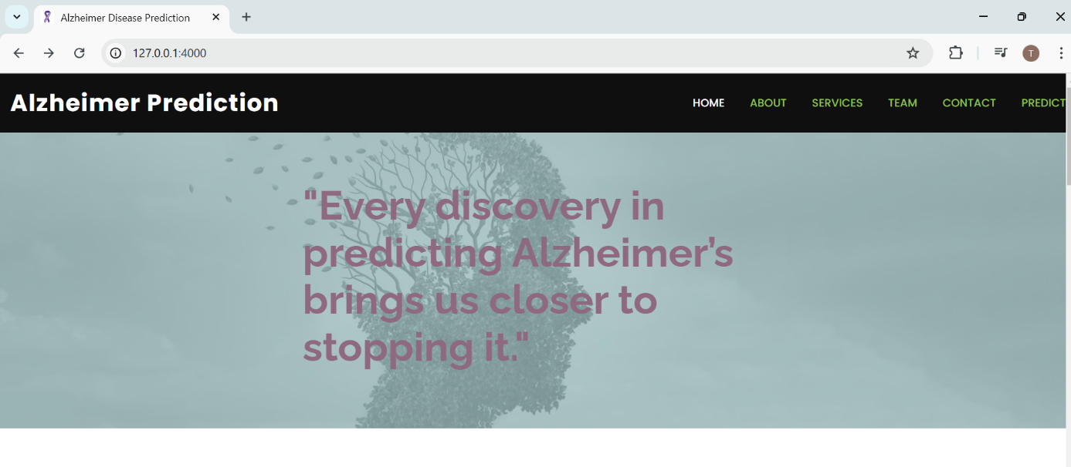

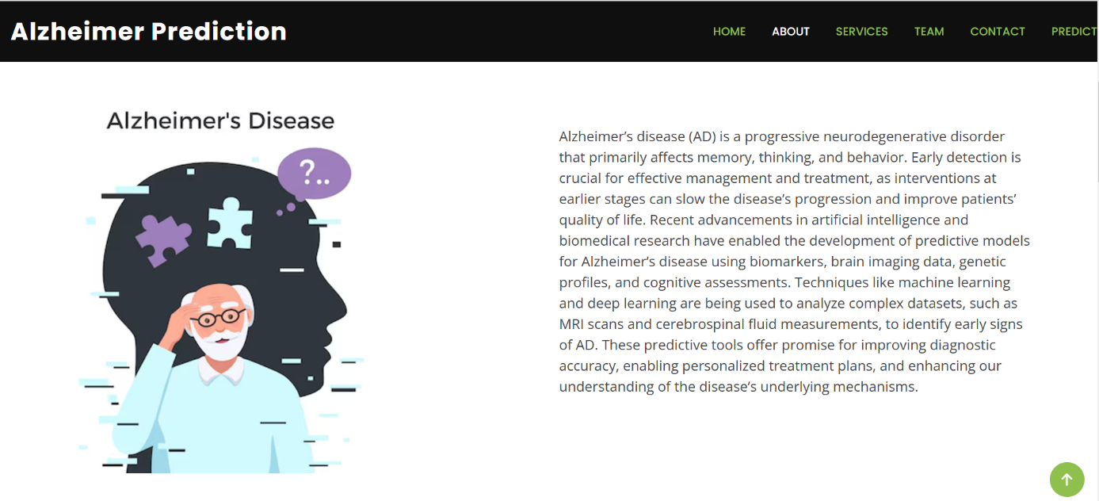

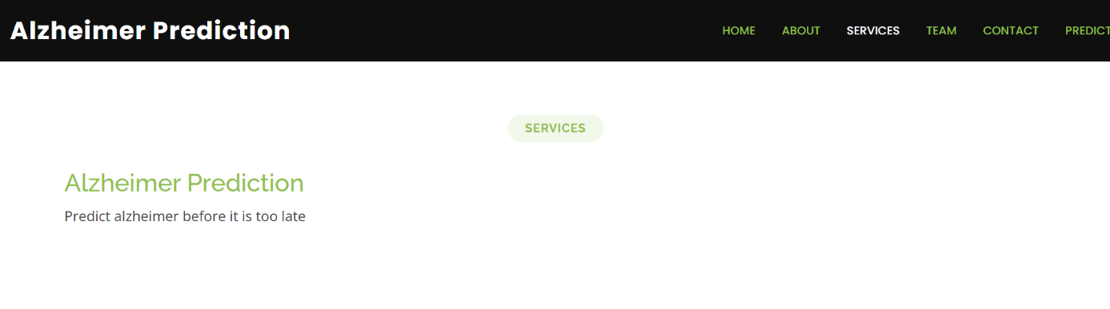

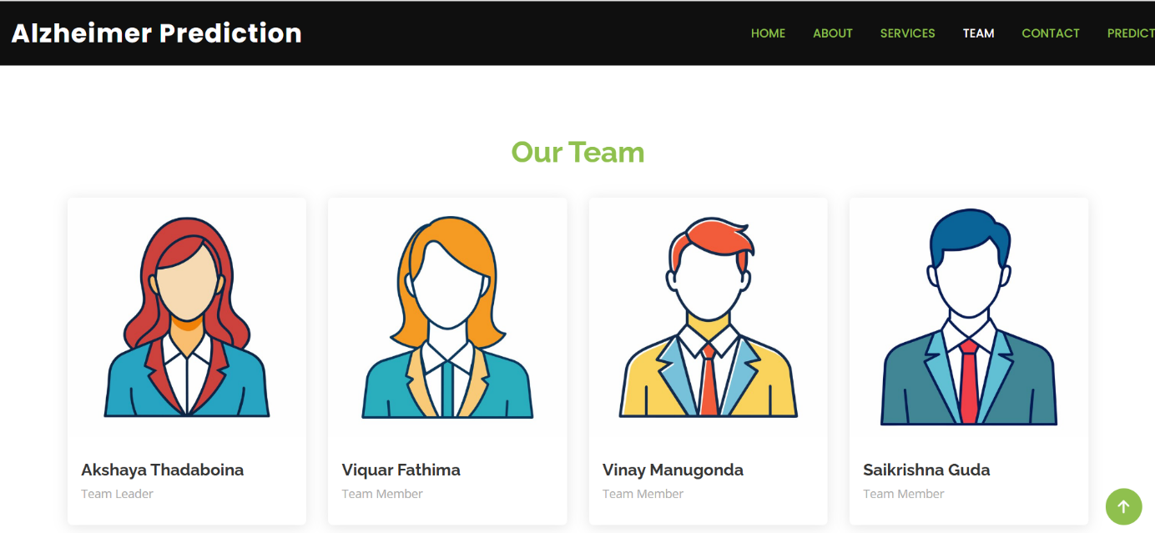

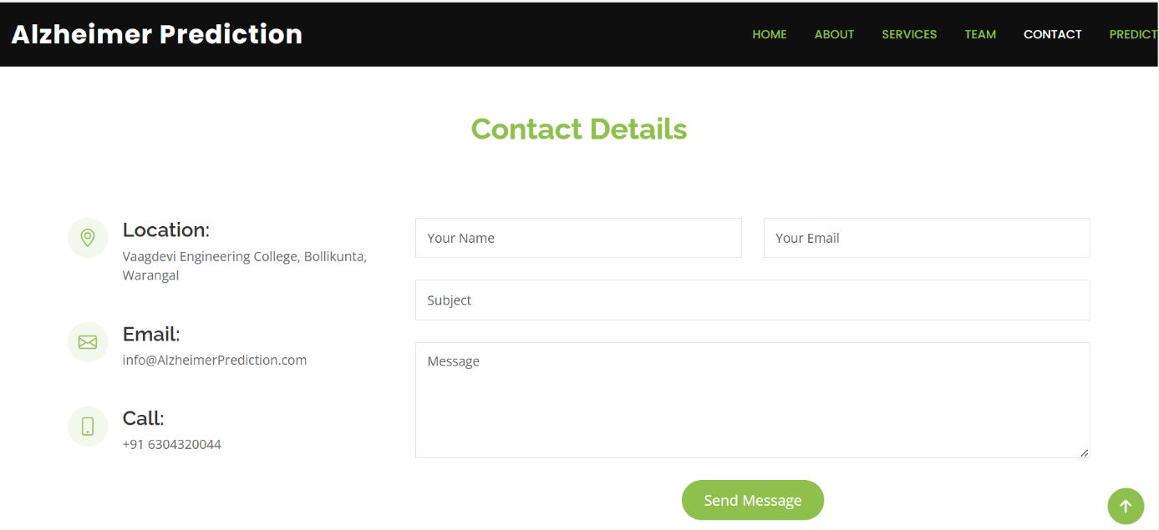

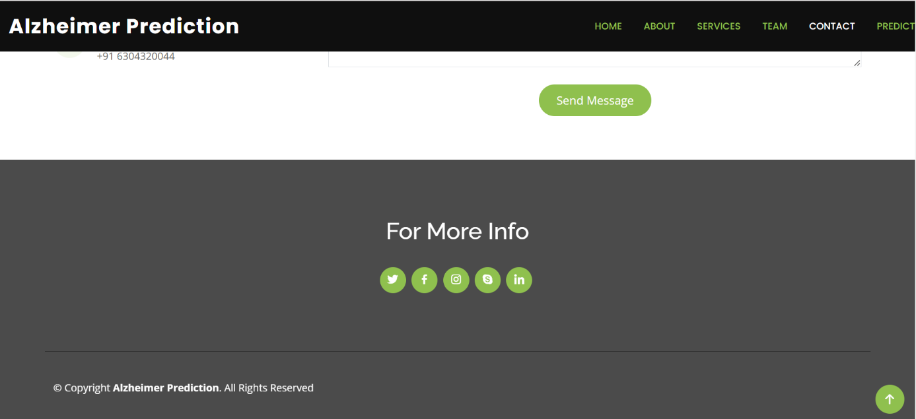

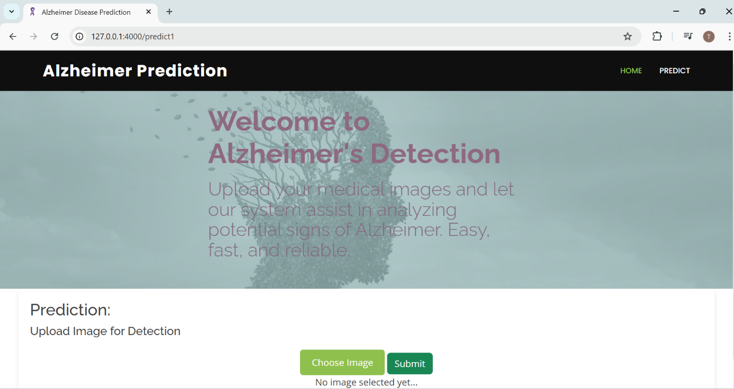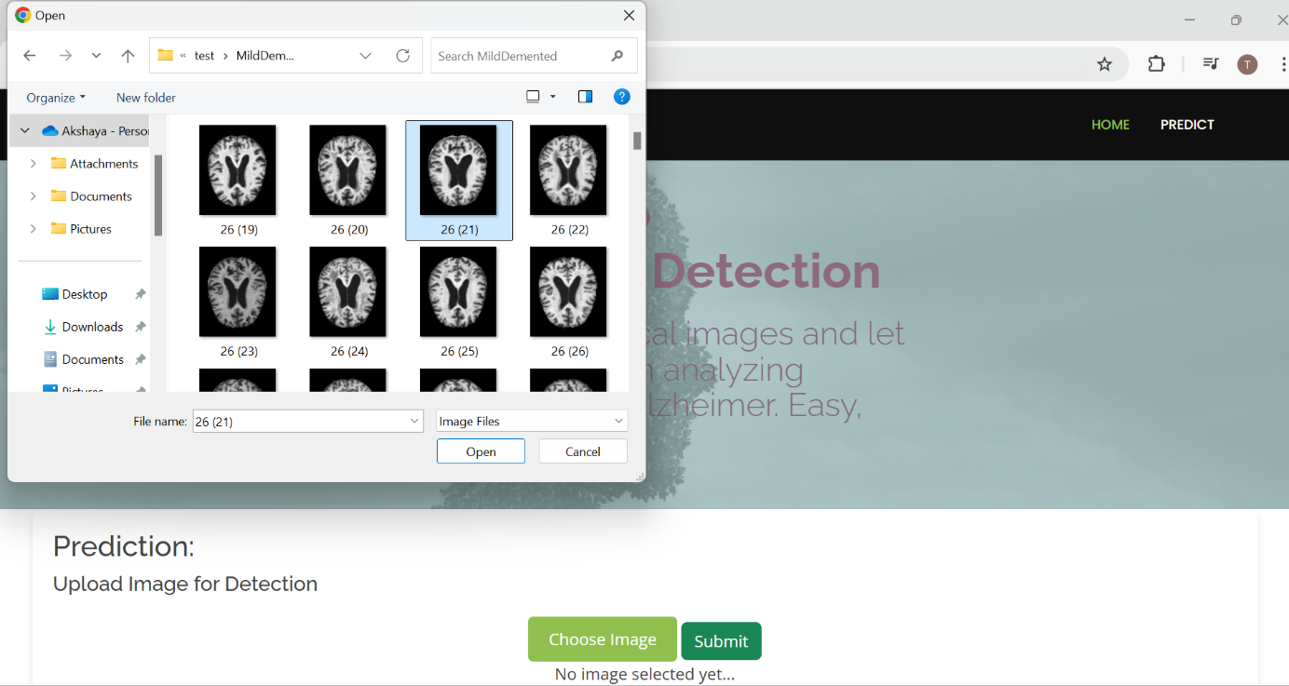

 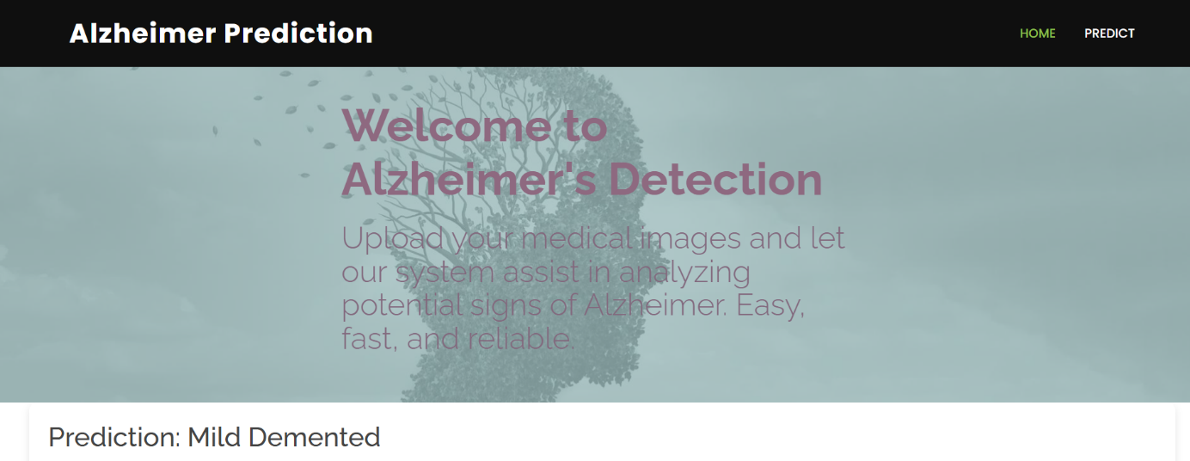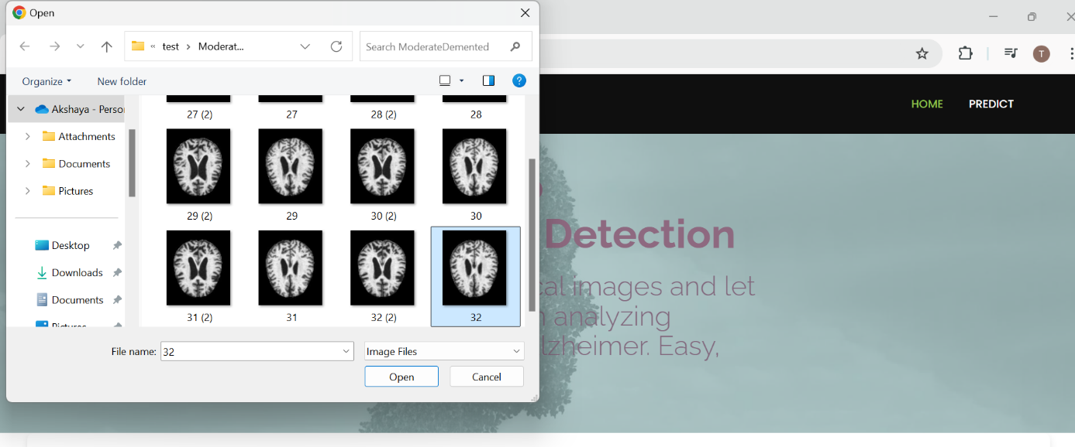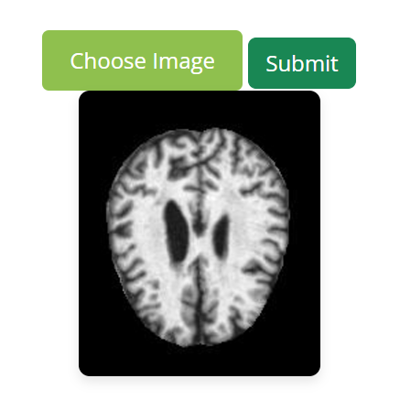

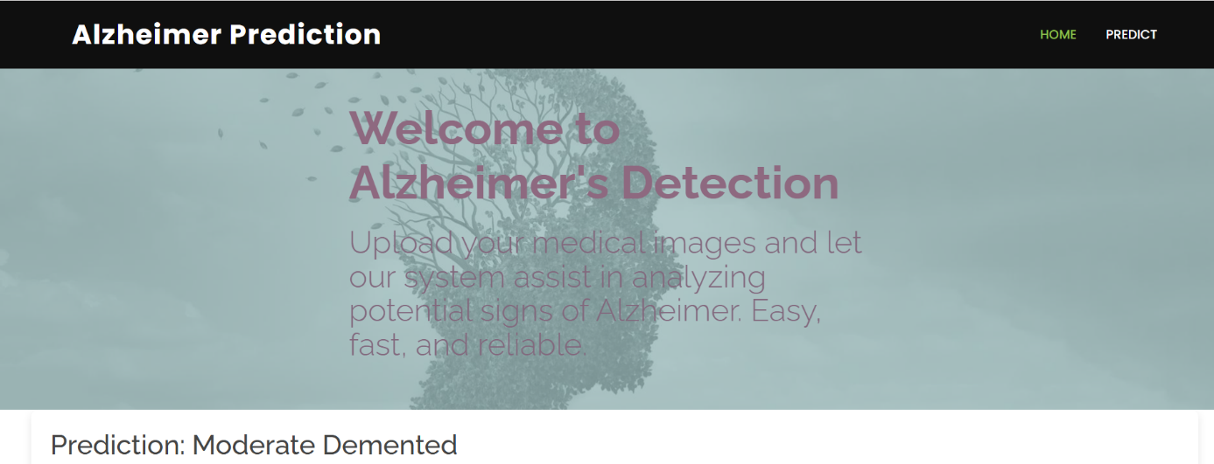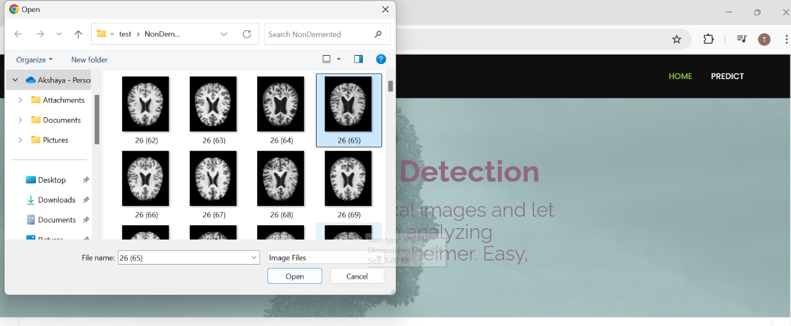

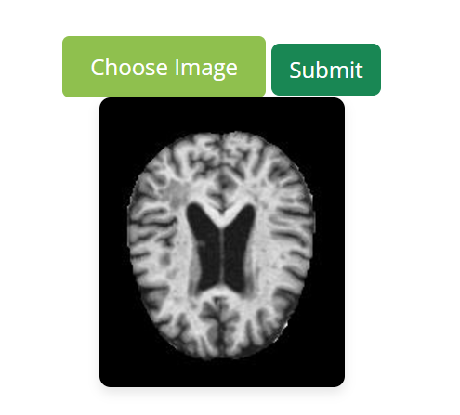

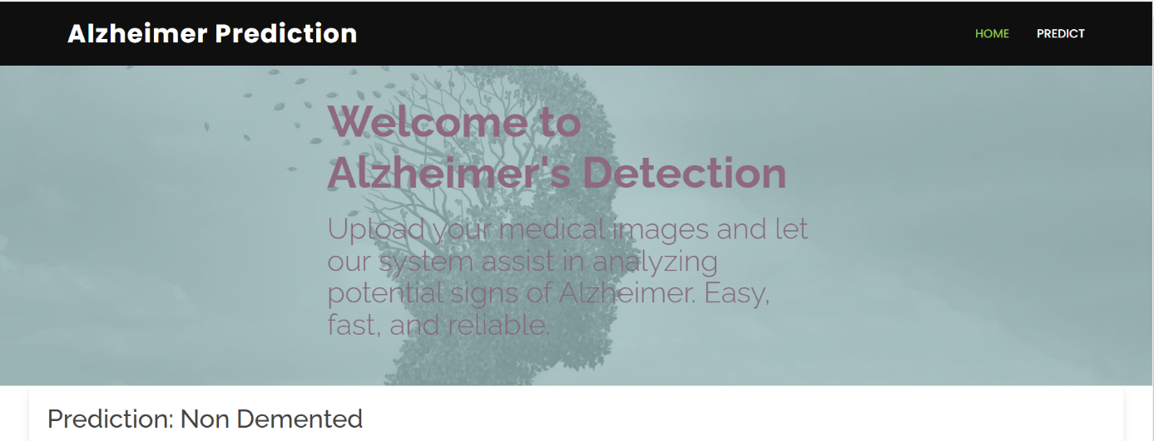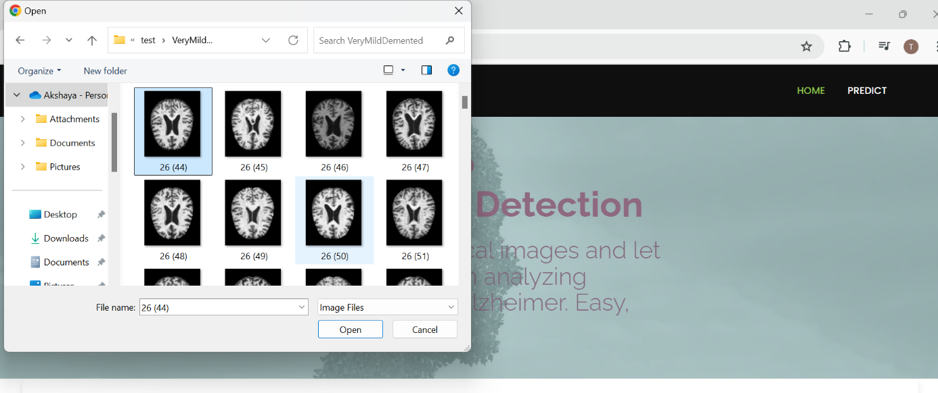

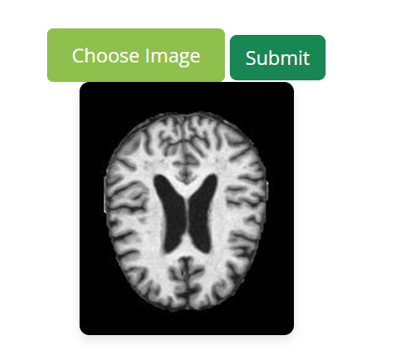

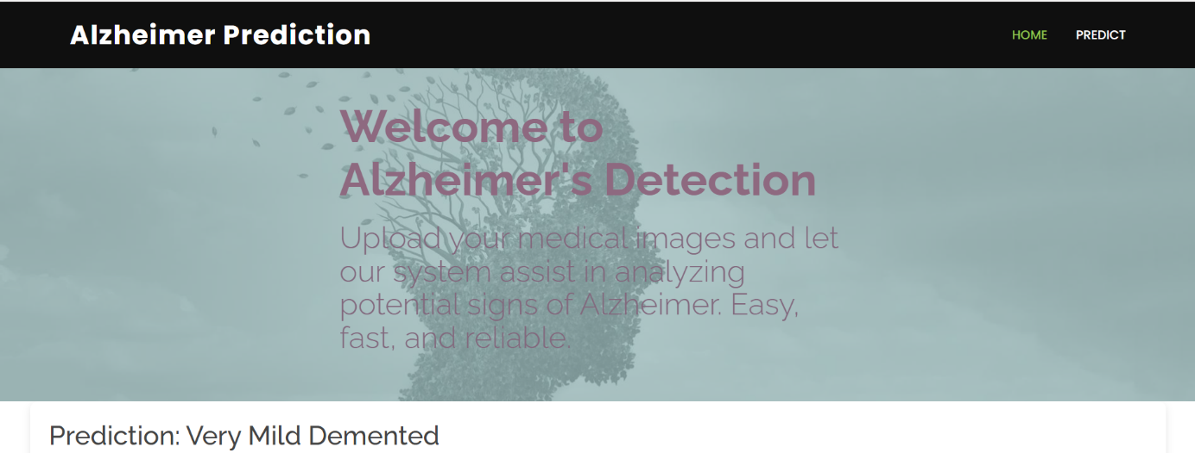

1. **Advantages:**

* **Early Detection:** Enables early identification of Alzheimer’s disease, allowing timely interventions and better management strategies.
* **Automation:** Reduces reliance on manual interpretation of brain imaging, saving time and minimizing human errors.
* **Scalability:** Can be applied to large datasets, making it suitable for widespread screening programs.
* **Accessibility:** Provides a user-friendly application that can assist healthcare professionals in diagnostics.
* **Cost-Effective:** Minimizes the need for expensive diagnostic tests by leveraging AI -based solutions.

**Disadvantages:**

* **Data Dependency:** Requires a large, high-quality dataset for training, which may be challenging to obtain.
* **Complexity:** Deep learning models are complex and may be difficult to interpret without explainable AI techniques.
* **Computational Resources:** Training and deploying the model require significant computational power and GPU resources.
* **Generalization Issues:** The model’s performance may vary across diverse populations and imaging modalities.
* **Ethical Concerns:** AI-based predictions may raise ethical questions about trust, bias, and data privacy in healthcare.

1. **Conclusion:**

In conclusion, the development of a deep learning-based solution for Alzheimer's disease prediction has the potential to revolutionize early diagnosis. By leveraging advanced techniques such as Convolutional Neural Networks (CNNs), this project provides a reliable, automated, and scalable diagnostic tool for healthcare professionals. The integration of this model into a user-friendly application ensures accessibility and usability, making it a valuable resource for clinical decision-making. While challenges such as data dependency and computational requirements exist, the benefits of early detection, improved patient outcomes, and reduced diagnostic costs underscore the significance of this approach in addressing the growing global impact of Alzheimer’s disease.

1. **Future Scope:**

* **Integration with Multimodal Data:** The model can be enhanced by incorporating additional clinical data such as cognitive test results, genetic information, and patient demographics to improve prediction accuracy.
* **3D Imaging Analysis:** Extending the approach to 3D Convolutional Neural Networks (3D-CNNs) for analyzing volumetric brain imaging data like full MRI scans could provide more comprehensive insights.
* **Real-Time Deployment:** The solution can be further optimized for real-time use in healthcare settings, enabling on-the-spot diagnostics during patient consultations.
* **Global Adaptability:** The model can be trained and fine-tuned on diverse datasets to ensure robust performance across different populations and imaging modalities.
* **Explainable AI Enhancements:** Advanced explainability methods could be integrated to provide clearer insights into the model’s decision-making process, improving trust and usability for clinicians.
* **Mobile and Cloud Integration:** Future developments could include deploying the model as a mobile app or a cloud-based service, increasing accessibility for researchers and healthcare providers globally.
* **Disease Progression Prediction:** The model could be adapted to predict the progression of Alzheimer’s disease over time, aiding in long-term treatment planning.
* **Collaboration with IoT Devices:** Integration with wearable health devices or brain activity monitors could enable continuous monitoring for high-risk individuals.

These advancements would further enhance the model’s utility, scalability, and impact in combating Alzheimer’s disease effectively.

1. **Appendix:**

**10.1 Source Code:**

**Home.html:**

<!DOCTYPE html>

<html lang="en">

<head>

<meta charset="utf-8">

<meta content="width=device-width, initial-scale=1.0" name="viewport">

<title>Alzheimer Disease Prediction</title>

<meta content="" name="description">

<meta content="" name="keywords">

<!-- Favicons -->

<link href="../static/assets/img/icon.png" rel="icon">

<!-- Vendor CSS Files -->

<link href="../static/assets/vendor/aos/aos.css" rel="stylesheet">

<link href="../static/assets/vendor/bootstrap/css/bootstrap.min.css" rel="stylesheet">

<link href="../static/assets/vendor/bootstrap-icons/bootstrap-icons.css" rel="stylesheet">

<link href="../static/assets/vendor/boxicons/css/boxicons.min.css" rel="stylesheet">

<link href="../static/assets/vendor/glightbox/css/glightbox.min.css" rel="stylesheet">

<link href="../static/assets/vendor/swiper/swiper-bundle.min.css" rel="stylesheet">

<!-- Template Main CSS File -->

<link href="../static/assets/css/style.css" rel="stylesheet">

</head>

<body>

<!-- ======= Header ======= -->

<header id="header" class="d-flex align-items-center">

<div class="container d-flex justify-content-between">

<div class="logo">

<h1 class="text-light"><a href="index.html">Alzheimer Prediction</a></h1>

</div>

</div>

<nav id="navbar" class="navbar">

<ul>

<li><a class="nav-link scrollto active" href="/#hero">Home</a></li>

<li><a class="nav-link scrollto" href="/#about">About</a></li>

<li><a class="nav-link scrollto" href="/#services">Services</a></li>

<li><a class="nav-link scrollto" href="/#team">Team</a></li>

<li><a class="nav-link scrollto" href="/#contact">Contact</a></li>

<a href="/predict1" class="get-started-btn scrollto">Predict</a>

<i class="bi bi-list mobile-nav-toggle"></i>

</nav><!-- .navbar -->

</div>

</header><!-- End Header -->

<!-- ======= Hero Section ======= -->

<section id="hero" class="d-flex align-items-center justify-content-center">

<div class="container" data-aos="fade-up">

<div class="row justify-content-center" data-aos="fade-up" data-aos-delay="150">

<div class="col-xl-6 col-lg-8">

<h1><span>"Every discovery in predicting Alzheimer’s brings us closer to stopping it."</span></h1>

</div>

</div>

</div>

</section><!-- End Hero -->

<main id="main">

<!-- ======= About Section ======= -->

<section id="about" class="about">

<div class="container" data-aos="fade-up">

<div class="row">

<div class="features-image col-lg-6" data-aos="fade-up" data-aos-delay="100"><img src="../static/assets/img/d.avif" alt=""></div>

<div class="col-lg-6">

<br>

<br>

<p>Alzheimer’s disease (AD) is a progressive neurodegenerative disorder that primarily affects memory, thinking, and behavior. Early detection is crucial for effective management and treatment, as interventions at earlier stages can slow the disease’s progression and improve patients’ quality of life. Recent advancements in artificial intelligence and biomedical research have enabled the development of predictive models for Alzheimer’s disease using biomarkers, brain imaging data, genetic profiles, and cognitive assessments. Techniques like machine learning and deep learning are being used to analyze complex datasets, such as MRI scans and cerebrospinal fluid measurements, to identify early signs of AD. These predictive tools offer promise for improving diagnostic accuracy, enabling personalized treatment plans, and enhancing our understanding of the disease’s underlying mechanisms.</p>

</div>

</div>

</div>

</section><!-- End about Section -->

<!-- ======= Services Section ======= -->

<section id="services" class="services">

<!-- Section Title -->

<div class="container section-title" data-aos="fade-up">

<h2>Services</h2>

</div><!-- End Section Title -->

<div class="container">

<div class="row gy-4">

<div class="col-lg-4 col-md-6" data-aos="fade-up" data-aos-delay="400">

<div class="service-item position-relative">

</div>

<a href="/predict1" class="stretched-link">

<h3>Alzheimer Prediction</h3>

</a>

<p>Predict alzheimer before it is too late</p>

</div>

</div><!-- End Service Item -->

</div>

</div>

</section><!-- End Services Section -->

<!-- ======= Team Section ======= -->

<section id="team" class="team">

<div class="container">

<div class="section-title" data-aos="zoom-in">

<h3><span>Our Team</span></h3>

</div>

<div class="row">

<div class="col-lg-3 col-md-6 d-flex align-items-stretch">

<div class="member" data-aos="fade-up">

<div class="member-img">

<img src="../static/assets/img/team/1.jpg" class="img-fluid" alt="">

<div class="social">

<a href=""><i class="bi bi-twitter"></i></a>

<a href=""><i class="bi bi-facebook"></i></a>

<a href=""><i class="bi bi-instagram"></i></a>

<a href=""><i class="bi bi-linkedin"></i></a>

</div>

</div>

<div class="member-info">

<h4>Akshaya Thadaboina</h4>

<span>Team Leader</span>

</div>

</div>

</div>

<div class="col-lg-3 col-md-6 d-flex align-items-stretch">

<div class="member" data-aos="fade-up">

<div class="member-img">

<img src="../static/assets/img/team/3.jpg" class="img-fluid" alt="">

<div class="social">

<a href=""><i class="bi bi-twitter"></i></a>

<a href=""><i class="bi bi-facebook"></i></a>

<a href=""><i class="bi bi-instagram"></i></a>

<a href=""><i class="bi bi-linkedin"></i></a>

</div>

</div>

<div class="member-info">

<h4>Viquar Fathima</h4>

<span>Team Member</span>

</div>

</div>

</div>

<div class="col-lg-3 col-md-6 d-flex align-items-stretch">

<div class="member" data-aos="fade-up">

<div class="member-img">

<img src="../static/assets/img/team/2.jpg" class="img-fluid" alt="">

<div class="social">

<a href=""><i class="bi bi-twitter"></i></a>

<a href=""><i class="bi bi-facebook"></i></a>

<a href=""><i class="bi bi-instagram"></i></a>

<a href=""><i class="bi bi-linkedin"></i></a>

</div>

</div>

<div class="member-info">

<h4>Vinay Manugonda</h4>

<span>Team Member</span>

</div>

</div>

</div>

<div class="col-lg-3 col-md-6 d-flex align-items-stretch">

<div class="member" data-aos="fade-up">

<div class="member-img">

<img src="../static/assets/img/team/4.jpg" class="img-fluid" alt="">

<div class="social">

<a href=""><i class="bi bi-twitter"></i></a>

<a href=""><i class="bi bi-facebook"></i></a>

<a href=""><i class="bi bi-instagram"></i></a>

<a href=""><i class="bi bi-linkedin"></i></a>

</div>

</div>

<div class="member-info">

<h4>Saikrishna Guda</h4>

<span>Team Member</span>

</div>

</div>

</div>

</div>

</div>

</section><!-- End Team Section -->

<!-- ======= Contact Section ======= -->

<section id="contact" class="contact">

<div class="container">

<div class="section-title" data-aos="zoom-in">

<h3><span>Contact Details</span></h3>

</div>

<div class="row mt-5">

<div class="col-lg-4" data-aos="fade-right">

<div class="info">

<div class="address">

<i class="bi bi-geo-alt"></i>

<h4>Location:</h4>

<p>Vaagdevi Engineering College, Bollikunta, Warangal</p>

</div>

<div class="email">

<i class="bi bi-envelope"></i>

<h4>Email:</h4>

<p>info@AlzheimerPrediction.com</p>

</div>

<div class="phone">

<i class="bi bi-phone"></i>

<h4>Call:</h4>

<p>+91 6304320044</p>

</div>

</div>

</div>

<div class="col-lg-8 mt-5 mt-lg-0">

<form action="forms/contact.php" method="post" role="form" class="php-email-form">

<div class="row">

<div class="col-md-6 form-group">

<input type="text" name="name" class="form-control" id="name" placeholder="Your Name" required>

</div>

<div class="col-md-6 form-group mt-3 mt-md-0">

<input type="email" class="form-control" name="email" id="email" placeholder="Your Email" required>

</div>

</div>

<div class="form-group mt-3">

<input type="text" class="form-control" name="subject" id="subject" placeholder="Subject" required>

</div>

<div class="form-group mt-3">

<textarea class="form-control" name="message" rows="5" placeholder="Message" required></textarea>

</div>

<div class="my-3">

<div class="loading">Loading</div>

<div class="error-message"></div>

<div class="sent-message">Your message has been sent. Thank you!</div>

</div>

<div class="text-center"><button type="submit">Send Message</button></div>

</form>

</div>

</div>

</div>

</section><!-- End Contact Section -->

</main><!-- End #main -->

<!-- ======= Footer ======= -->

<footer id="footer"

<div class="footer-top">

<div class="container">

<div class="row justify-content-center">

<div class="col-lg-6">

</div>

</div>

<div><h2>For More Info</h2></div>

<div class="social-links">

<a href="#" class="twitter"><i class="bx bxl-twitter"></i></a>

<a href="#" class="facebook"><i class="bx bxl-facebook"></i></a>

<a href="#" class="instagram"><i class="bx bxl-instagram"></i></a>

<a href="#" class="google-plus"><i class="bx bxl-skype"></i></a>

<a href="#" class="linkedin"><i class="bx bxl-linkedin"></i></a>

</div>

</div>

</div>

<div class="container footer-bottom clearfix">

<div class="copyright">

&copy; Copyright <strong><span>Alzheimer Prediction</span></strong>. All Rights Reserved

</div>

<div class="credits">

<!-- All the links in the footer should remain intact. -->

<!-- You can delete the links only if you purchased the pro version. -->

<!-- Licensing information: https://bootstrapmade.com/license/ -->

<!-- Purchase the pro version with working PHP/AJAX contact form: https://bootstrapmade.com/remember-free-multipurpose-bootstrap-template/ -->

</div>

</div>

</footer><!-- End Footer -->

<div id="preloader"></div>

<a href="#" class="back-to-top d-flex align-items-center justify-content-center"><i class="bi bi-arrow-up-short"></i></a>

<!-- Vendor JS Files -->

<script src="../static/assets/vendor/purecounter/purecounter_vanilla.js"></script>

<script src="../static/assets/vendor/aos/aos.js"></script>

<script src="../static/assets/vendor/bootstrap/js/bootstrap.bundle.min.js"></script>

<script src="../static/assets/vendor/glightbox/js/glightbox.min.js"></script>

<script src="../static/assets/vendor/isotope-layout/isotope.pkgd.min.js"></script>

<script src="../static/assets/vendor/swiper/swiper-bundle.min.js"></script>

<script src="../static/assets/vendor/php-email-form/validate.js"></script>

<!-- Template Main JS File -->

<script src="../static/assets/js/main.js"></script>

</body>

</html>

**Innerpage.html:**

<!DOCTYPE html>

<html lang="en">

<head>

<meta charset="utf-8">

<meta content="width=device-width, initial-scale=1.0" name="viewport">

<title>Alzheimer Disease Prediction</title>

<meta content="" name="description">

<meta content="" name="keywords">

<!-- Favicons -->

<link href="../static/assets/img/icon.png" rel="icon">

<!-- Vendor CSS Files -->

<link href="../static/assets/img/icon.jpg" rel="icon">

<link href="../static/assets/vendor/bootstrap/css/bootstrap.min.css" rel="stylesheet">

<link href="../static/assets/vendor/bootstrap-icons/bootstrap-icons.css" rel="stylesheet">

<link href="../static/assets/vendor/boxicons/css/boxicons.min.css" rel="stylesheet">

<link href="../static/assets/vendor/glightbox/css/glightbox.min.css" rel="stylesheet">

<link href="../static/assets/vendor/swiper/swiper-bundle.min.css" rel="stylesheet">

<!-- Template Main CSS File -->

<link href="../static/assets/css/style.css" rel="stylesheet">

</head>

<body>

<!-- ======= Header ======= -->

<header id="header" class="d-flex align-items-center">

<div class="container d-flex justify-content-between">

<div class="logo">

<h1 class="text-light"><a href="inspect.html">Alzheimer Prediction</a></h1>

<!-- Uncomment below if you prefer to use an image logo -->

<!-- <a href="index.html"><img src="assets/img/logo.png" alt="" class="img-fluid"></a>-->

</div>

<nav id="navbar" class="navbar">

<ul>

<li><a class="nav-link scrollto" href="/">Home</a></li>

<li><a class="nav-link scrollto" href="/#hero">Predict</a></li>

</ul>

<i class="bi bi-list mobile-nav-toggle"></i>

</nav><!-- .navbar -->

</div>

</header><!-- End Header -->

<!--Hero section-->

<section id="hero" class="d-flex align-items-center justify-content-center">

<div class="container" data-aos="fade-up">

<div class="row justify-content-center" data-aos="fade-up" data-aos-delay="150">

<div class="col-xl-6 col-lg-8">

<h1>Welcome to Alzheimer's Detection</h1>

<p><h4>Upload your medical images and let our system assist in analyzing potential signs of Alzheimer. Easy, fast, and reliable.</h4></p>

</div>

</div>

</div>

</section>

<section class="main-content" id="upload">

<h3>Prediction: {{ result }}</h3>

<h5>Upload Image for Detection</h5>

<form action="/predict" method="POST" enctype="multipart/form-data">

<div class="upload-section">

<input type="file" id="imageInput" name="image" accept="image/*">

<label for="imageInput">Choose Image</label>

<button type="submit" class="btn btn-success">Submit</button>

<div class="image-preview" id="imagePreview">

<p>No image selected yet...</p>

</div>

</div>

</form>

</section>

<!--End Hero section-->

</main>

<div id="preloader"></div>

<a href="#" class="back-to-top d-flex align-items-center justify-content-center"><i class="bi bi-arrow-up-short"></i></a>

<!-- Vendor JS Files -->

<script src="../static/assets/vendor/purecounter/purecounter_vanilla.js"></script>

<script src="../static/assets/vendor/aos/aos.js"></script>

<script src="../static/assets/vendor/bootstrap/js/bootstrap.bundle.min.js"></script>

<script src="../static/assets/vendor/glightbox/js/glightbox.min.js"></script>

<script src="../static/assets/vendor/isotope-layout/isotope.pkgd.min.js"></script>

<script src="../static/assets/vendor/swiper/swiper-bundle.min.js"></script>

<script src="../static/assets/vendor/php-email-form/validate.js"></script>

<!-- Template Main JS File -->

<script src="../static/assets/js/main.js"></script>

</body>

</html>

**App.py:**

import os

import numpy as np

from flask import Flask, request, render_template

from keras.preprocessing import image

from werkzeug.utils import secure_filename

from tensorflow.keras.models import load_model

# Initialize Flask App

app = Flask(__name__)

# Load the model

model = load_model('adp.h5')

@app.route('/', methods=['GET'])

def index():

return render_template('home.html')

@app.route('/predict1', methods=['GET'])

def predict1():

return render_template('innerpage.html')

@app.route('/predict', methods=['POST'])

def upload():

if 'image' not in request.files:

return "No file uploaded", 400

f = request.files['image']

basepath = os.path.dirname(__file__)

uploads_path = os.path.join(basepath, 'uploads')

os.makedirs(uploads_path, exist_ok=True) # Ensure uploads folder exists

file_path = os.path.join(uploads_path, secure_filename(f.filename))

try:

f.save(file_path)

except Exception as e:

return f"Error saving file: {str(e)}", 500

# Preprocess the image

try:

img = image.load_img(file_path, target_size=(180, 180))

x = image.img_to_array(img)

x = np.expand_dims(x, axis=0)

x = x / 255.0 # Normalize

# Predict

prediction = model.predict(x)

label = np.argmax(prediction, axis=1)[0] # Get class index

# Map predictions to labels

labels = {

0: "Mild Demented",

1: "Moderate Demented",

2: "Non Demented",

3: "Very Mild Demented"

}

result = labels.get(label, "Unknown Prediction")

except Exception as e:

return f"Error processing the image: {str(e)}", 500

return render_template('innerpage.html', result=result)

if __name__ == "__main__":

app.run(port=4000, debug=False)

**10.2 GitHub & Project Demo Link:** [**Click Here**](https://github.com/Akshaya-143/Alzheimer-Disease-Prediction/tree/main/Alzheimer)